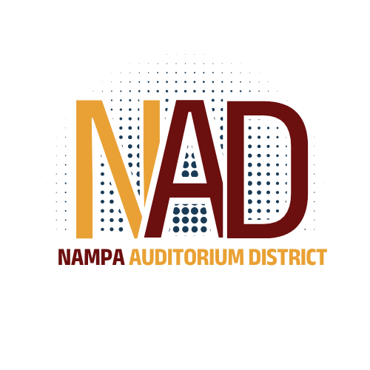 | NAMPA AUDITORIUM DISTRICT  Regular Meeting  Home2Suites – 5860 E Franklin Rd Nampa, ID 83687  Syringa Room  July 13, 2026  12:30 PM
All items on the agenda are action items in which a vote may be taken, unless designated as discussion only. I.C. 74-204(4)
Call to Order

Roll Call

(1) | Minutes

1-1. | Action Item: June 8, 2026 Regular Meeting Minutes

(2) | Financials

2-1.
  Action Item: Accept or reject Financial Report and Payables

(3) | Administrative Report

3-1. | Admin Report Memo

(4) | New Business

4-1. | Action Item: Authorize Chair to sign Local Government Investment Pool New Entity Application, staff to transmit application and complete required administrative tasks to establish an account

4-2. | Discussion Item: Discuss cash management policy

Adjournment

